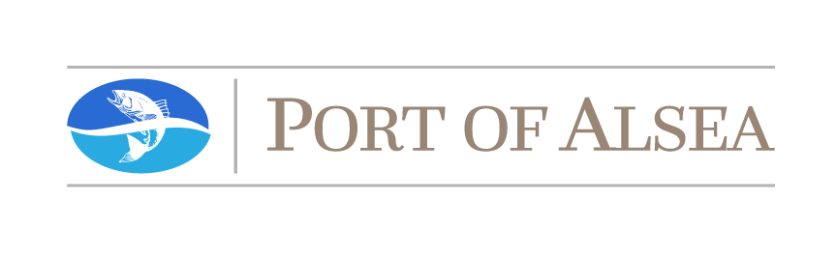
2019 PORT OF ALSEA NEWSLETTER

Board of Commissioners:
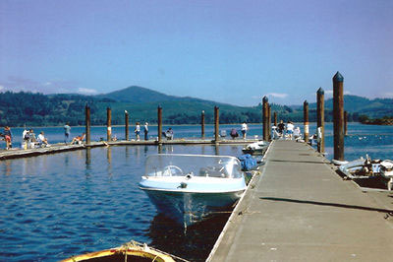
Rob Bishop, President
Jan Power, Vice-President
Ramon (Buster) Pankey, Sec / Treas.
Chuck Pavlik
Joe Rohleder

Staff:
Roxie Cuellar, Port Manager
Robby Hensen, Maintenance
Nick Rust, Maintenance

Contact Information:

Office Address: 365 Port Street, Waldport, OR 97394
Office Mailing Address: P. O. Box 1060, Waldport, OR 97394
Office Phone Number: 541-563-3872
Office Email Address: rcuellar@portofalsea.com

Message from the Commission President Rob Bishop:
The Port Commissioners and staff are disappointed that we had to delay the construction of the new boat launch and marina until November, 2020, but we continue to work on means of moving the Port in a forward direction. The Port commissioners and staff strive to find new ways for the Port of Alsea to better serve its residents with recreational opportunities on the water. That may mean new types of recreation or it may mean providing familiar activities in new locations, such as kayaking on the Yachats River or swimming at Eckman Lake. The goal of the Port of Alsea is to provide children and adults with memorable experiences at and on the waterways in the Port District. If you have suggestions, the Port would love to hear from you. The Port exists to serve you.

Who are the People Who Work for You?
The Port has five volunteer commissioners who serve on the Board of Commissioners and are identified above. The Board establishes Port policies and oversees the work of the port manager. Each commissioner is elected by Port District residents for a four-year term. The Port typically has three employees - the port manager, and two maintenance personnel. All of the positions are part-time.
What New Projects Were Finished by the Port in 2019?
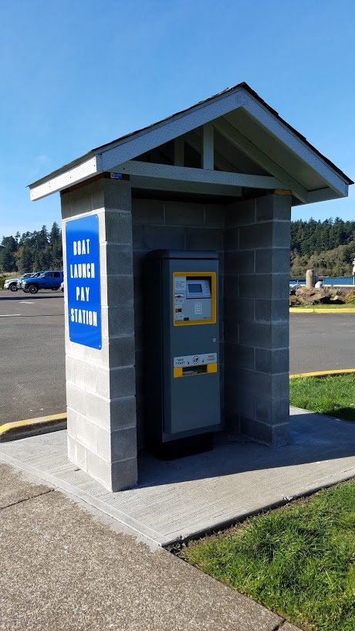
With help from Lincoln County and students and instructors from Angell Job Corps, the Port was able to install a new electronic pay station to replace the metal pay box that was previously located at the top of the boat ramp. Lincoln County gave the Port a $13,219.00 grant to pay for the pay station. The Job Corps students, supervised by the Job Corps staff, poured the concrete slab and constructed the block walls; the Port paid for the materials. The new pay station is located just past the stop sign on Broadway rather than at the top of the boat launch, so people are not paying to launch in the same place where other people are backing their boats down the ramp to launch. The new pay station takes credit cards and $1 and $5 bills, but it does not give change. The pay station became available the last part of July and has proven to be very popular. It is much quicker for boaters to use than filling out the envelopes that were required with the former pay box. It saves a lot of staff time because most people pay with credit cards and those payments are sent directly to the Port’s bank account by the pay station software. The software allows to the staff to monitor payments from the office computer. The machine is designed to thwart theft attempts and activity at the pay station is constantly recorded on the Port’s security cameras as well.
A new electronic Pay Station
The Port used bond measure funds, as approved by the voters, to upgrade the public bathrooms. The shingle roof was replaced by a metal roof with new skylights, the toilets, urinal, and hand dryers are now operated by motion detectors, new stall doors, lights, and mirrors were installed, the interior walls painted and the exterior walls pressure washed, the soffits painted, and a new floor surface was poured. The stainless steel fixtures were retained but steam cleaned and polished, except for the urinal which was replaced. The public bathrooms are now ready for Port guests to use for many more years to come.
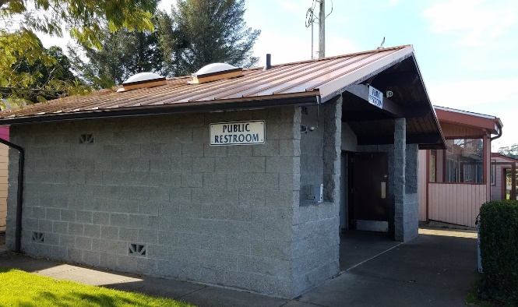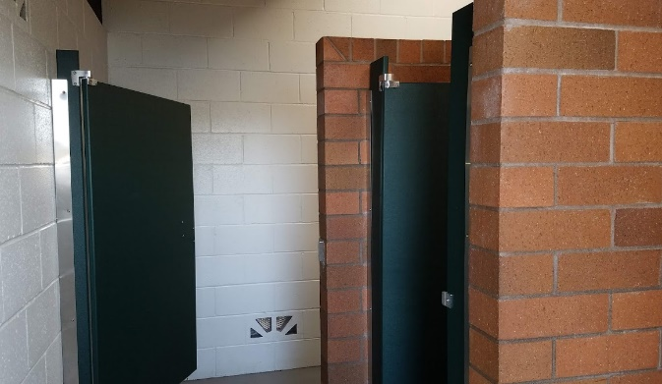
Exterior of Port’s Public Restrooms Restroom Interior
Why Couldn’t the Marina Construction Begin in November of 2019?
The marina construction essentially involves five distinct projects: (1) constructing the boat launch and the onsite amenities, such the bioswale to collect and filter stormwater from the top of the boat launch, and widening the launch approach to two lanes across from the stop sign on Broadway; (2) construction of the marina, an ADA multi-use platform and a multi-use float for crabbing, fishing, and a kayak launch, (3) removing chunks of concrete on the beach on the north side of the bay east of the bridge as a mitigation project to compensate for the increased size of the boat launch, (4) the removal of an earthen dam on the north side of the bay across from Eckman Lake to compensate for extending the life of the current marina (a new National Marines Fisheries Service [NMFS] requirement); and (5) dredging. In all, three permits were required from both the State of Oregon through the Department of State Lands (DSL) and the federal government through the Army Corps of Engineers. By September, we had received all three permits for the boat launch, the marina, and dredging from the state. However, by early October we had not received the marina permit and the dredging permit from the Corps. In-water work cannot start until November 1 and must be completed by February 15, although we could probably get an extension until the end of February. Without the marina and dredging permits from the Corps, Bergerson Construction strongly advised that the Port put the entire project off for a year to maximize efficiencies and because Bergerson could not guarantee that they could complete the in-water work during the 3½ to four month in-water work period, especially without knowing when the two permits needed from the Corps would be received. The Board of Commissioners reluctantly made the necessary decision to postpone the project until November, 2020. Bergerson guaranteed to do the project for the same cost. The floats are being constructed now and other needed materials are being ordered and stored so Bergerson Construction and the Port can hit the ground running next year.
The floats on the docks will be made of two frames and a grated surface. The frame sitting on the water is constructed of tubes made of very durable HDPE plastic which provides easy maintenance. Barnacles, for example, reportedly do not stick to it. A second frame of hot-dipped galvanized steel sits atop the tubular frame, with the grated surface on top of that. The commissioners first opted for aluminum frames rather than hot-dipped galvanized steel, but the engineers were concerned that metal fatigue could be a problem with aluminum. The fiberglass grated surface will have the maximum amount of grit to provide optimal slip resistance. Federal and state agencies are urging the use of the grated surfaces now for environmental reasons. These floats represent the next generation in dock construction. The Port’s goal is to have floats that will last for decades.
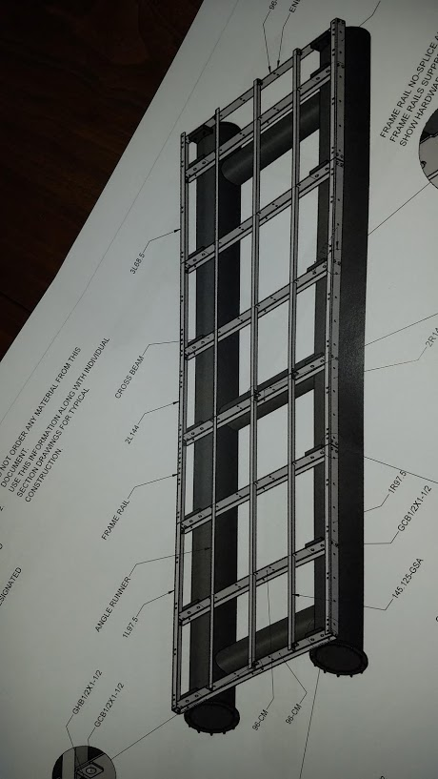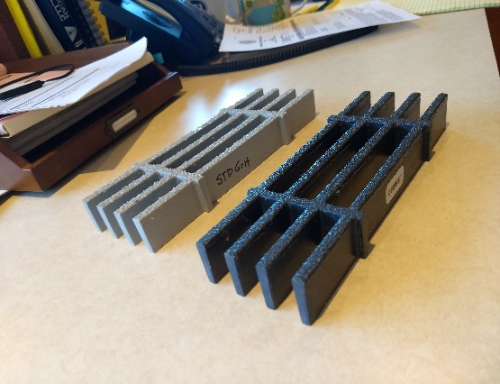
Tubular and Hot-Dipped Galvanized Steel Frames Fiberglass Grated and Gritted Float Surface
The year-long delay has at least one silver lining. Most of the remaining $1.9 million of bond funds in the Local Government Investment Pool account will continue to draw interest for another year (the $1.9 million does not include the $350,000 grant from the Marine Board and Oregon Fish and Wildlife toward the construction of the boat launch, which will be provided at construction). Even though interest rates have gone down and invoices have been paid, the account still collected more than $3,500 in interest in November. That extra money can be used to help fund the necessary dredging in the marina. The Port has also applied for an additional $105,000 in grants for the marina project, which will free up additional funds for dredging.
Oregon Department of Fish and Wildlife has awarded a $100,000 grant to the Port to help pay for the construction of the ADA crabbing / fishing platform and the multi-use float. In the past, the Port has never prohibited fishing on the docks but it has not encouraged it either because of the potential conflict of uses between people sitting in their lawn chairs on the docks after tossing in their crab pots, and those casting their lines in the midst of the crabbers. However, crabbing methods have changed. More and more people are now using reels to cast for crabs rather than using pots. The change is understandable. For crabbers who are only looking to catch two or three crabs, the reels and triangles used by people casting for crabs are lighter to carry to the docks and are perhaps more fun as an activity. Whether the Port will need to designate areas on the docks for “casters” as a safety precaution or whether casters and traditional crabbers can intermingle together on the docks is something that the Port will keep a watchful eye on.
The Port has also applied for a $5,000 grant from Special Districts Association of Oregon for a Safety and Security grant. The grant would be used to offset the cost of proving ladders and safety cabinets on the new docks. The Port will continue to look for other grant opportunities as well.
What Is the Current State of the Port’s Finances?
The Port has paid for the dredging permit out of the general fund rather than the bond money and that has cost approximately $15,000. Nevertheless, after property taxes have arrived by mid-December, the Port will have approximately $115,000 in its general fund in the Local Government Investment Pool and in its general fund in its local bank account. The Port’s revenue is seasonal, like many local businesses, so it sees a decline in income between January and June, then begins to see a positive cash flow in July of each year. However, the Port’s expenses also come down as winter arrives. As always, adjustments are made in employees’ hours because of the slowdown, although it continues to annually increase employees’ wages and salary. Unfortunately, the Port still cannot not afford to offer much in the way of benefits other than vacation and sick time and $150 a year clothing allowance for maintenance employees. The anticipated boat launch closure cost the Port some revenue this year from lost launch fees and moorage and that will presumably happen again next year when the construction is scheduled to begin. The Port hopes to see increased revenues from the new marina, but those goals are now delayed for another year. The Port probably did not lose a lot of financial ground this year because of modest increases in other revenues, but it did not gain ground either, which is always the Port’s goal. Fortunately, some expenses this year, such as the dredging permit, are one-time expenses and should not be repeated in future years.
What Goals Does the Port Have for the Future?
The Port always looks for ways to bring more activities to the Port facilities for local residents to enjoy and to enable them to become better acquainted with the Port itself. For years, port commissioner Joe Rohleder has helped sponsor an annual fishing event at the state capital in Salem. Two large portable pools are stocked with 700 to 800 half-pound trout for which children aged 12 and under fish. Fishing gear is provided, as well as casting instruction if desired, and fish that are caught are cooked on site and served with side dishes and beverages. It is a very popular event at the capital. Commissioner Rohleder has now arranged for this tradition in Salem to also be held annually at the Port of Alsea. In selecting a date for the event, the commissioners wanted a reasonable chance for nice weather before the Port gets into its busy season, but one that would not conflict with Beachcomber Days. The Port is planning the inaugural event for June 27, 2020, the last Saturday in June. The Port will advertise the date in the spring with hopes that providing a fishing event for children will become a popular tradition at the Port of Alsea.
Completing the new marina facilities in the spring of 2021 rather than 2020 allows time for the Port to focus on other projects this winter. The need for additional parking is as urgent as ever. The Port will be looking at grant opportunities to help develop additional parking south and west of the current parking on Broadway. It will also be looking at the cost to pave the parking lot behind the Dock of the Bay. Though the new marina has been delayed for a year, the Port hopes to install the kayak launch for use this coming spring, which will add to the pressure on the east parking lot off Mill Street.
Paving that parking lot would allow the Port to paint permanent lines designating spaces which provides better efficiency - one way to add more parking spaces at relatively little cost. It is parking for vehicles and attached boat trailers on Broadway, however, that has the highest priority. It would probably initially be a graveled lot. A paved lot would be more expensive and would probably need to be engineered to obtain the correct storm water runoff into the detention pond at the southwest corner of the current lot. When paving the east parking lot, it would probably be most efficient to finish paving the current parking lot behind and south of the shop building at the same time. The bottom line is always cost and the Port will have another year to work on that.
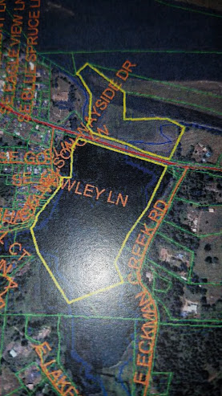
The Port is also starting some very preliminary work engaging with state agencies about improving the condition of Eckman Lake. Obviously, necessary permits would need to be obtained from the state and the Corps to do any work at the lake. While the Port owns most of Eckman Lake, neighboring property owners are also stakeholders in how the lake is managed, as well as all of the Port District residents. The WB Nelson State Recreation Site, owned and managed by the State of Oregon, is located on the west side of the lake and has docks for fishing and the tie-up of small boats. The portion of Eckman Lake owned by the Port of Alsea is shown in the picture on the left with the Port’s ownership outlined in yellow.
The Port will look at partnering with state agencies, such as Oregon Department of Parks and Recreation and Oregon Department of Fish and Wildlife, to achieve the outcomes desired by the residents of the Port district. The Port also hopes to work with the Watershed Council to best utilize its expertise.
Longtime residents remember people swimming and water skiing on Eckman Lake in the past and many would like to see the lake used for recreational purposes again. Others may prefer to see the lake kept as much as possible in a natural state. The goal of the Port would be to develop a plan that could offer benefits for everyone’s vision of the lake.
The Port could perhaps opt to limit any boats on the lake to those without gasoline engines as a compromise between those who wish the lake to be maintained as a tidal estuary and those who wish the lake to be a recreational site. It may be an appropriate place for the Port to install a canoe / kayak launch. However, no decisions would be made by the Port commissioners about the future of Eckman Lake without the Port district residents having ample opportunities to weigh in on the various options. Before that can happen, however, the Port needs to learn what the various options are. For example, can the Port even impose limits on the types of boats on the portion of the lake under Port ownership? The Port needs to start answering those kinds of questions first before it can start seeking input. This is a long-term project, but the Port is starting to work on it now.
The Port wants the port residents and others to view the Port of Alsea as a destination point, where individuals and families can find activities to enjoy. Obviously boating is a primary activity at the Port, but ideally just one of many. Whether crabbing or fishing on the docks, walking dogs, picnicking at Robinson Park, or sitting on a bench enjoying the view of the bay, the Port is here to serve you. The Port would always like to hear from you how it can best improve its service.
Enjoy the holidays. The Port wishes all of you a safe and prosperous New Year.

